# Overview of consolidated Technical Specification

Table of Contents

Technical Specification 1

1. Requirement Details 6

1.1 Summary of Requirements 6

1.2 Functional / Business description 6

1.3 Design Alternative (Mandatory) 6

1.4 Process Flow Diagram < User Interaction with the system in detailed> (Mandatory) 6

1.5 Peer Review 6

2. Reports/Layouts 7

2.1 Input/Selection screen parameters 7

2.2 Output Format for Reports/Layouts 7

3. Layouts (Additional info) 8

3.1 Printing Existing solutions 8

3.2 New Layout Requirements 8

4. User Exit / Enhancement Details 9

5. Business Add-in (BADI) 10

6. Module Pools 11

Screen Flow Diagram 11

List of screens 11

7. Other Development Objects 12

8. Custom / Z tables 13

9. Interfaces 14

10. Development Logic 15

11. Security [Mandatory] 16

12. Message handling 17

13. Impact Analysis: [Mandatory for all changes] 18

13.1 Impact on processes including application controls: No Impact 18

13.2 Impact on data: No Impact 18

13.3 Impact on end users: No Impact 18

13.4 Impact on Interfaces with other systems: No Impact 18

13.5 Impact on Operational procedures: No Impact 18

13.6 Impact on Infrastructure: No Impact 18

13.7 Impact on System / DB Admin: No Impact 18

14. Test cases (State reasons if any of the testing is not applicable) 19

14.1 Unit testing: 19

14.2 Integration testing: 19

14.3 Interface testing: 19

14.4 Volume/ Stress testing: 19

14.5 Security testing: 19

14.6 Data conversion testing: 19

15. Deployment Plan (Applicable for NON SAP application) 20

# Requirement Details

## Summary of Requirements

Requirement of this Report is to measure the average time between ZPMM work orders raised within SAP PM in the period.

* **ZPM_MTBF** T-Code is developed to execute **KPI MTBF (Mean Time Between Failure).**
* Fetch ZPMM work orders raised within SAP PM in the period based on Equipment Number (EQUNR), Plant(WERKS), Period (Month, Year), Week, Operating Hours, and Include Sundays (Checkbox)

## Functional / Business description

## Design Alternative (Mandatory)

NA.

## Process Flow Diagram < User Interaction with the system in detailed> (Mandatory)

**ZPM_MTBF Report**

Processing

SELECTION SCREEN

Execute

START

ZPM_MTBF

Output

Mandatory

(ZPM_MTBF)

RESULT

USER INPUT

STOP

## Peer Review



# Reports/Layouts

## Input/Selection screen parameters

(Provide layout of selection-screen if there are any specific alignment requirements other than standard)

|  |  |  |  |  |  |  |  |  |  |
| --- | --- | --- | --- | --- | --- | --- | --- | --- | --- |
| Table Field Name | Logical grouping of fields within boxes | Input options | | | | Other comments | Default Value | Drop down / Search Help | |
|  |  |  |  |  |  |  |  |  |

**The Selection screen for ZPM_MTBF.**

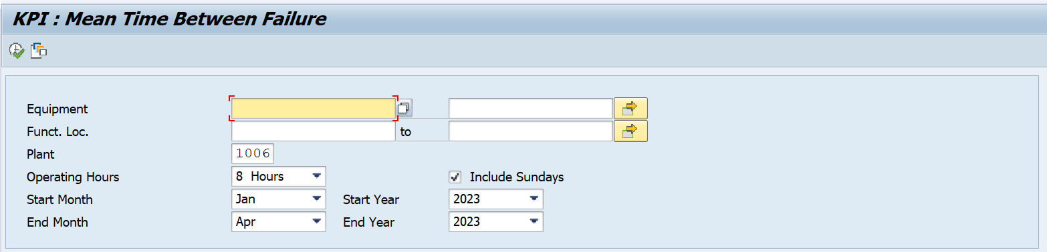

## Output Format for Reports/Layouts

**Layout of the ZPM_MTBF report screen.**

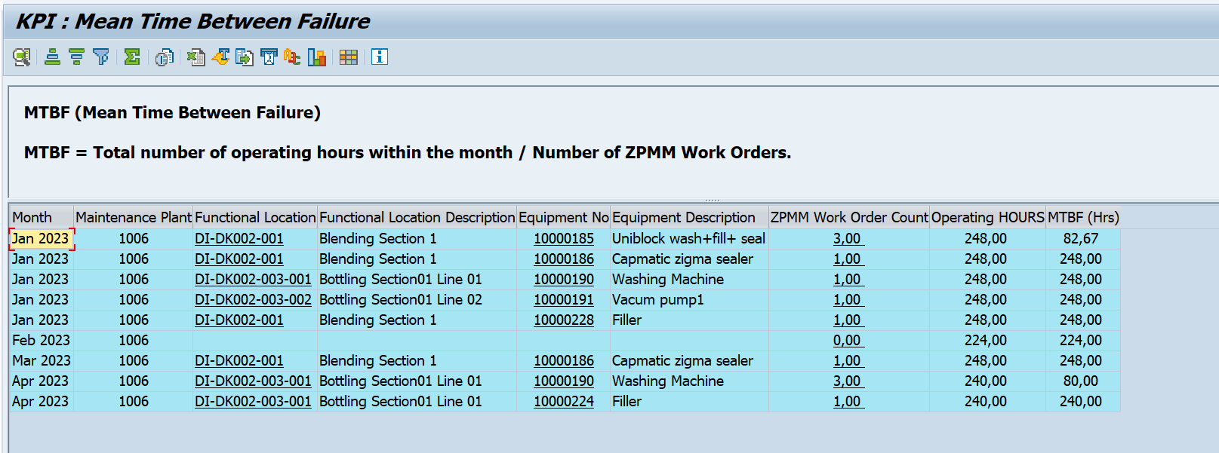

# Layouts (Additional info)

## Printing Existing solutions

|  |  |
| --- | --- |
| Output type (Printer) |  |
| Program Name |  |
| Layout Form Name |  |

## New Layout Requirements

|  |  |
| --- | --- |
| Output type (Printer) |  |
| Page Format  (with ref to Page size) |  |
| Orientation (Portrait/Landscape) |  |
| Font |  |
| Font size |  |

# User Exit / Enhancement Details

|  |  |
| --- | --- |
| Enchantement | NA |
| Component / Exit name / Function module | NA |
| Transactions impacted | NA |

# Business Add-in (BADI)

|  |  |
| --- | --- |
| Definition | NA |
| Method | NA |
| Transactions impacted | Na |
| Implementation name | NA |
|  |  |

# Module Pools

Screen layouts to be provided.

### Screen Flow Diagram

### List of screens

|  |  |
| --- | --- |
| Screen no. | Description |
|  |  |
|  |  |
|  |  |

# Other Development Objects

All other objects like function modules, Search helps, Field exits, Form exits etc. which have not been classified earlier and which need to be created should be explained here.

|  |
| --- |
| FM Name |
| REUSE_ALV_GRID_DISPLAY |
| VRM_SET_VALUES |
| VRM_SET_VALUES |
| WEEK_GET_FIRST_DAY |
| NUMBER_OF_DAYS_PER_MONTH_GET |

|  |
| --- |
| Class Name |
| NA |
|  |
|  |

|  |
| --- |
| Include name |
| NA |
|  |
|  |

# Custom / Z tables

NA.

# Interfaces

Write the interface names and the interface type.

# Development Logic

* Created the **ZR_PM_KPIMTBF** standalone executable program. (Report)
* Created z t-code for this report which is **ZPM_MTBF**.
* Initialization of local, global variable, structure, work areas and internal table. 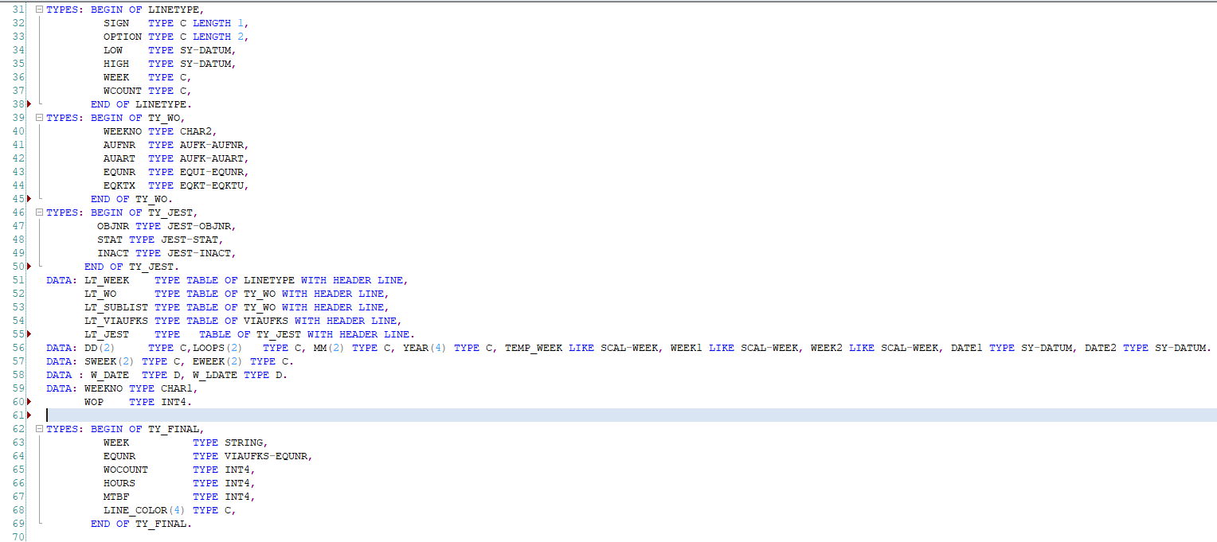
* Creating required selection screen as per functional specification. 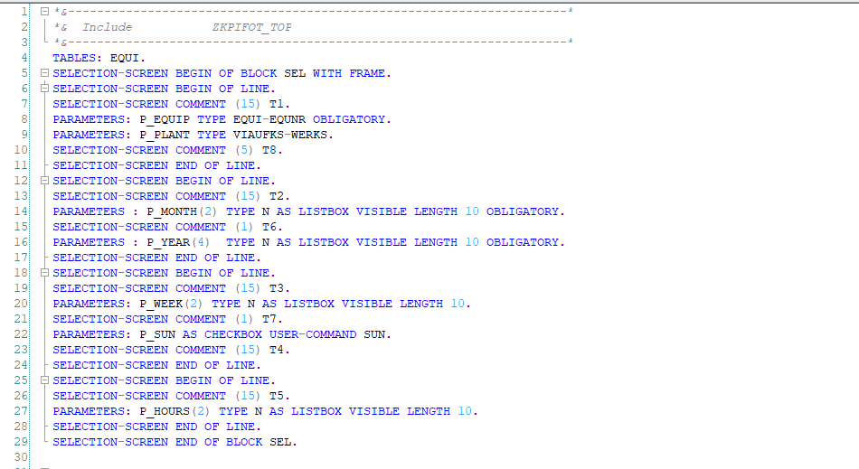
* Main Logic.

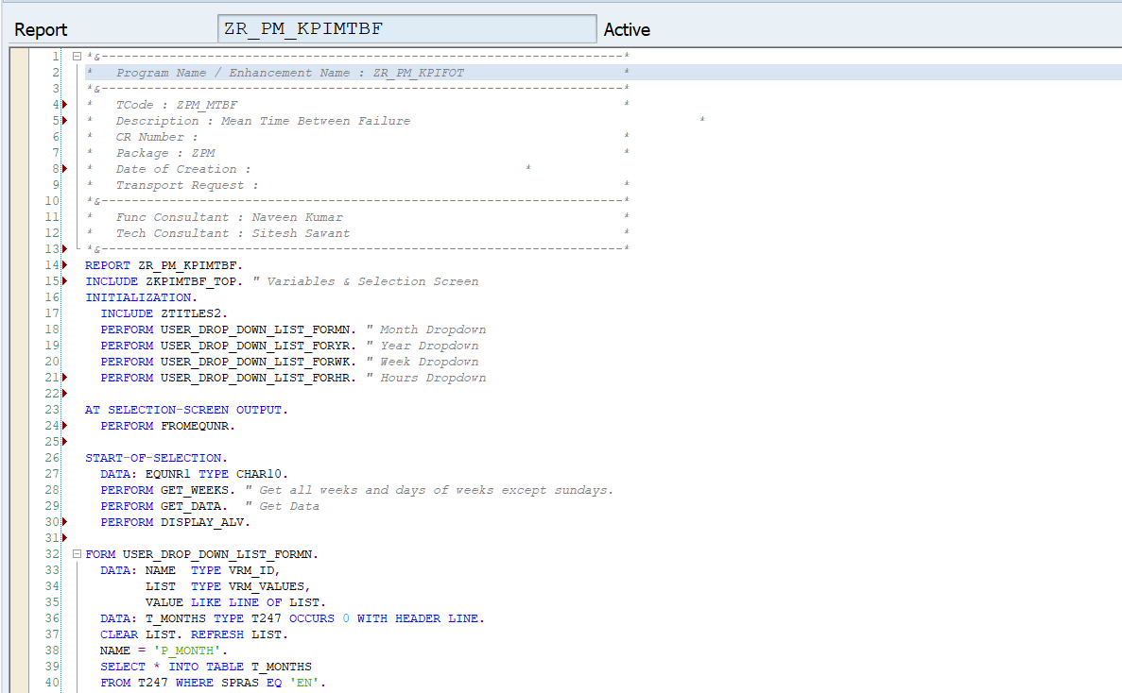

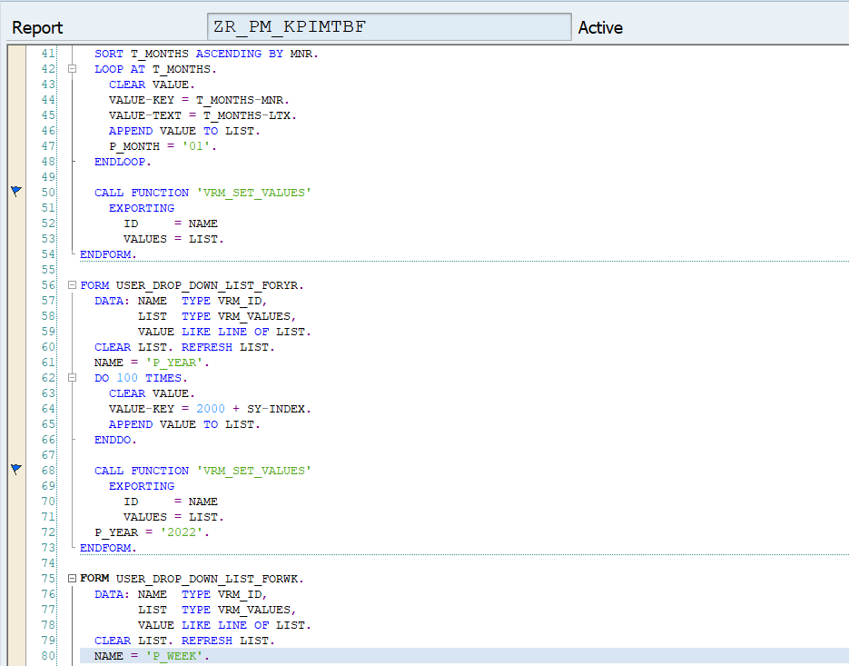

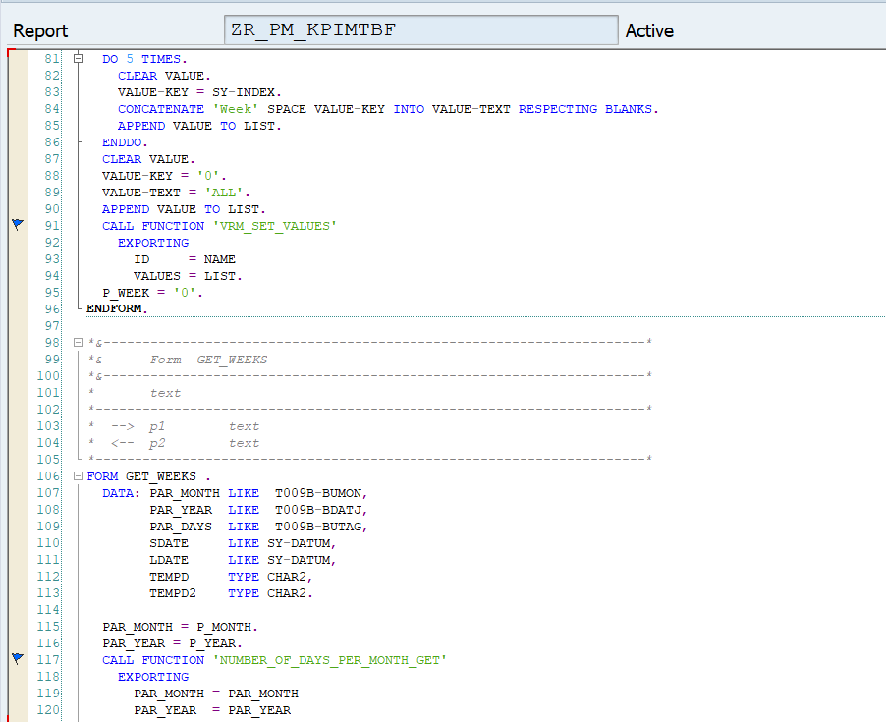

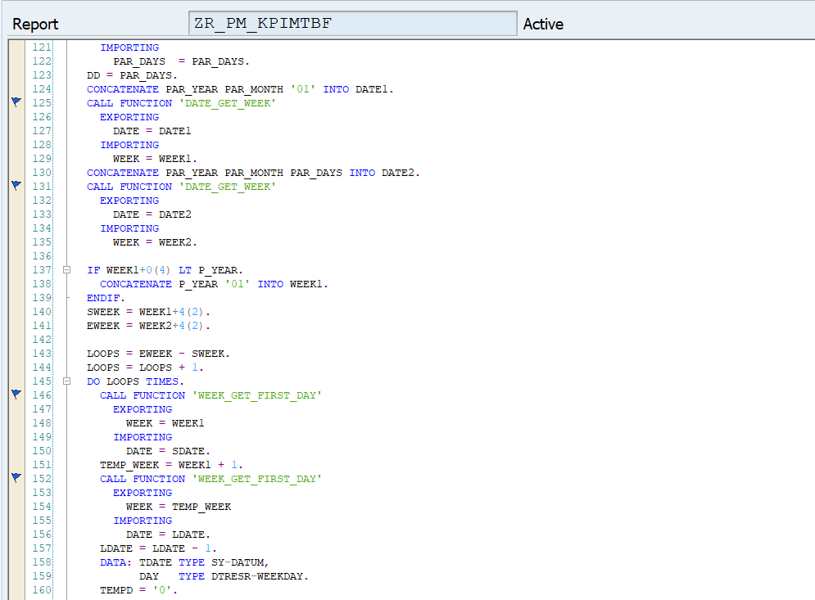

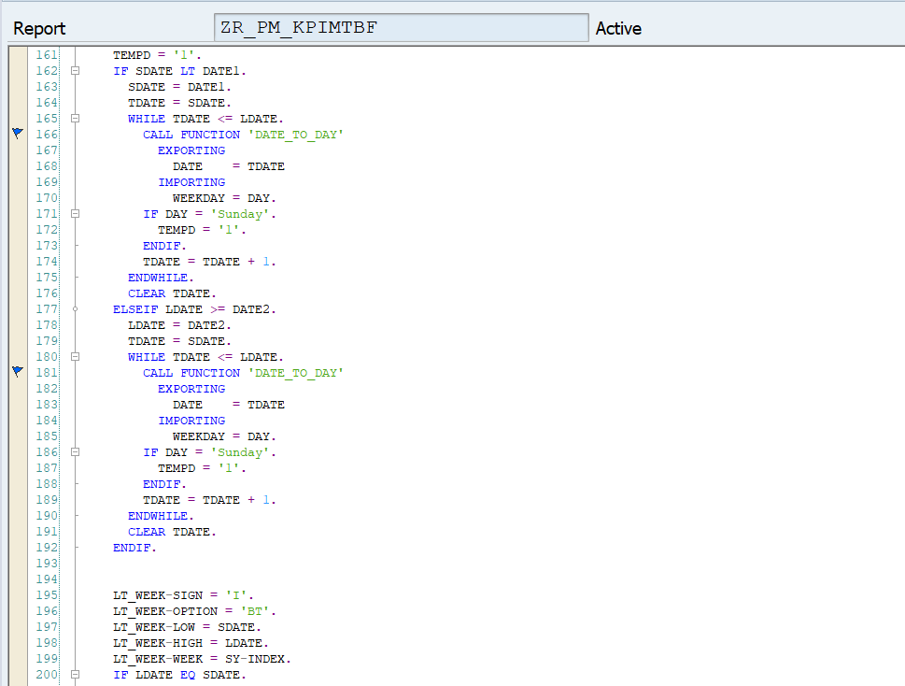

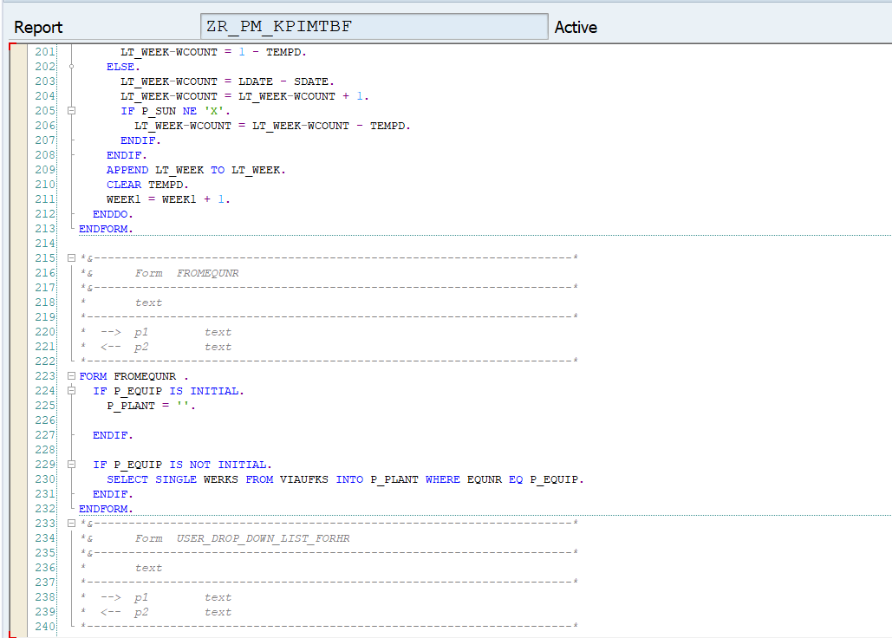

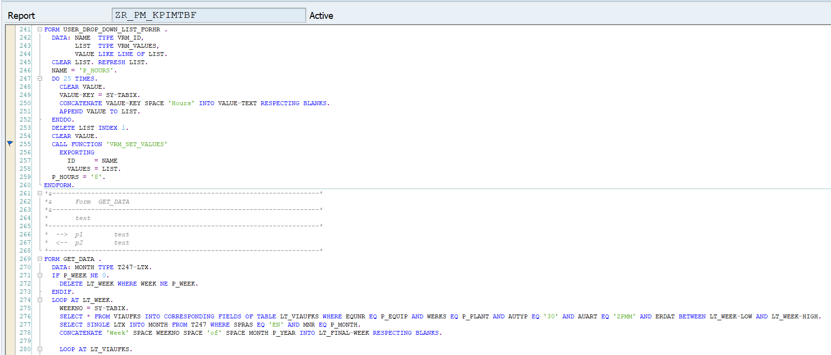

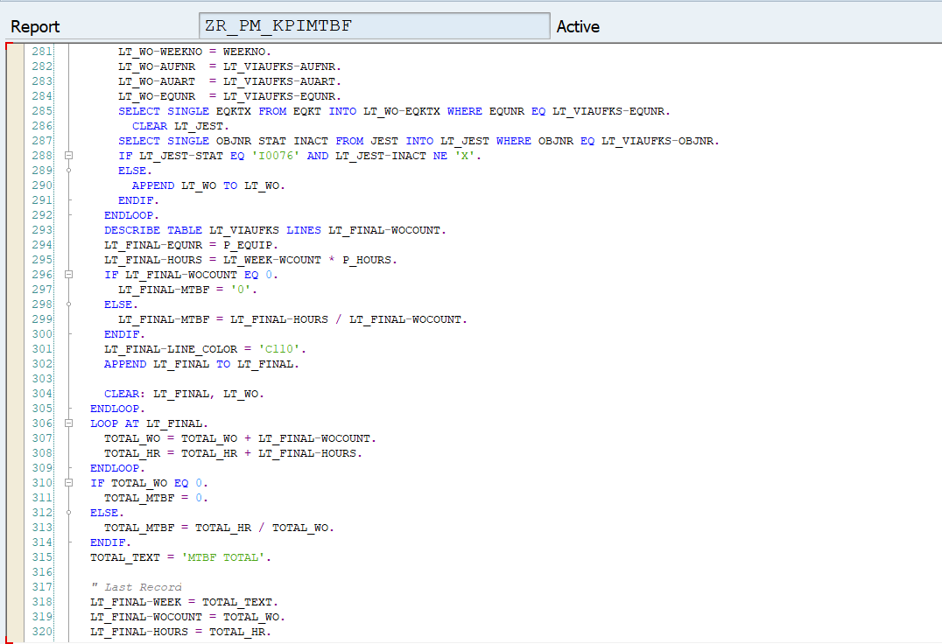

* Creating field catalogue to display result in pre-defined format.(ALV)

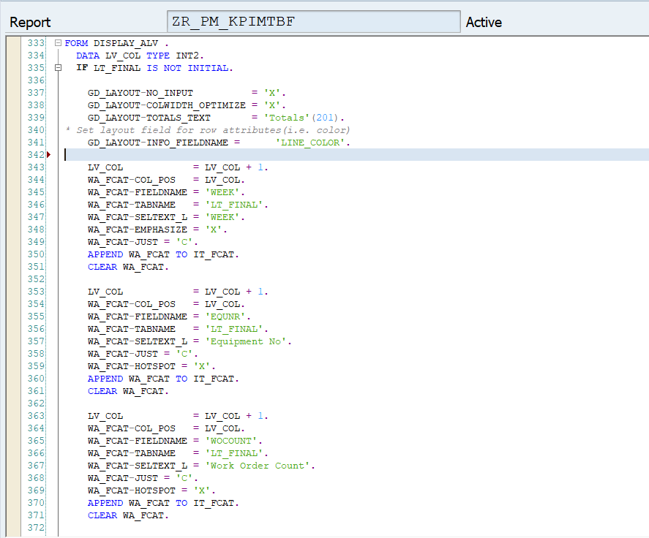

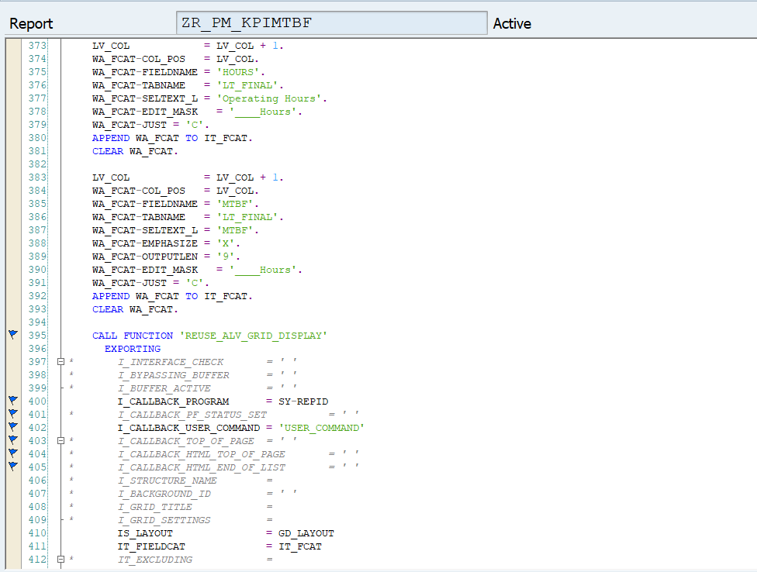

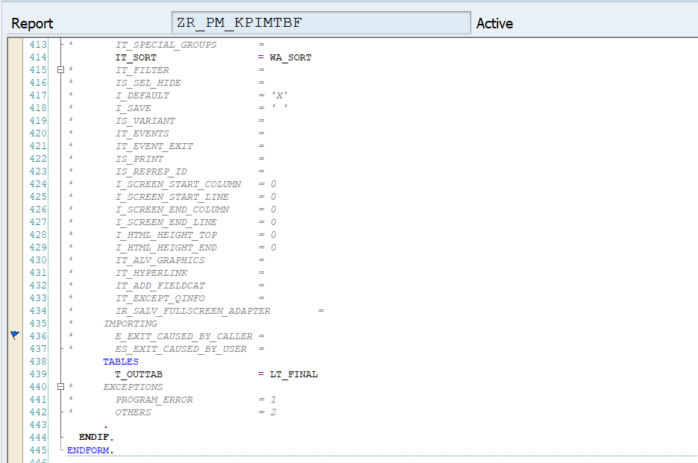

# Security [Mandatory]

**“The change does not use / create any new authorization objects. Therefore this is Not Applicable” else provide user role**

# Message handling

|  |  |  |  |
| --- | --- | --- | --- |
| Scenario | Message text | Type of message  (Error, Warning, Success) | Corrective Action if any |
|  |  |  |  |

# Impact Analysis: [Mandatory for all changes]

## Impact on processes including application controls: No GR document will be created once we save PO with unticked value in NON GR IV field

## Impact on data: No Impact

## Impact on end users: No need to create GR for two way match PO

## Impact on Interfaces with other systems: Ariba

## Impact on Operational procedures: No Impact

## Impact on Infrastructure: No Impact

## Impact on System / DB Admin: No Impact

# Test cases (State reasons if any of the testing is not applicable)

## Unit testing:

|  |  |  |
| --- | --- | --- |
| Test Case  Sl no. | Test Case Description | Expected Result |
|
|  |  |  |
|  |  |  |

## Integration testing:

NA – As this a technical change

## Interface testing:

NA – As this a technical change

## Volume/ Stress testing:

NA – As volume is not much

## Security testing:

NA – As there is no changes in security roles

## Data conversion testing:

NA – There is no conversion involved.

# Deployment Plan (Applicable for NON SAP application)

* Section 13 and 14 will be applicable only if FS is not there, else delete or use for Technical test cases if any